**Name:** Nishan Paul

**ID:** 1604085

**Course Title:** Computer Graphics (Sessional)

**Course No:** CSE-458

**Level 4, Term 1**

**Assignment 09**

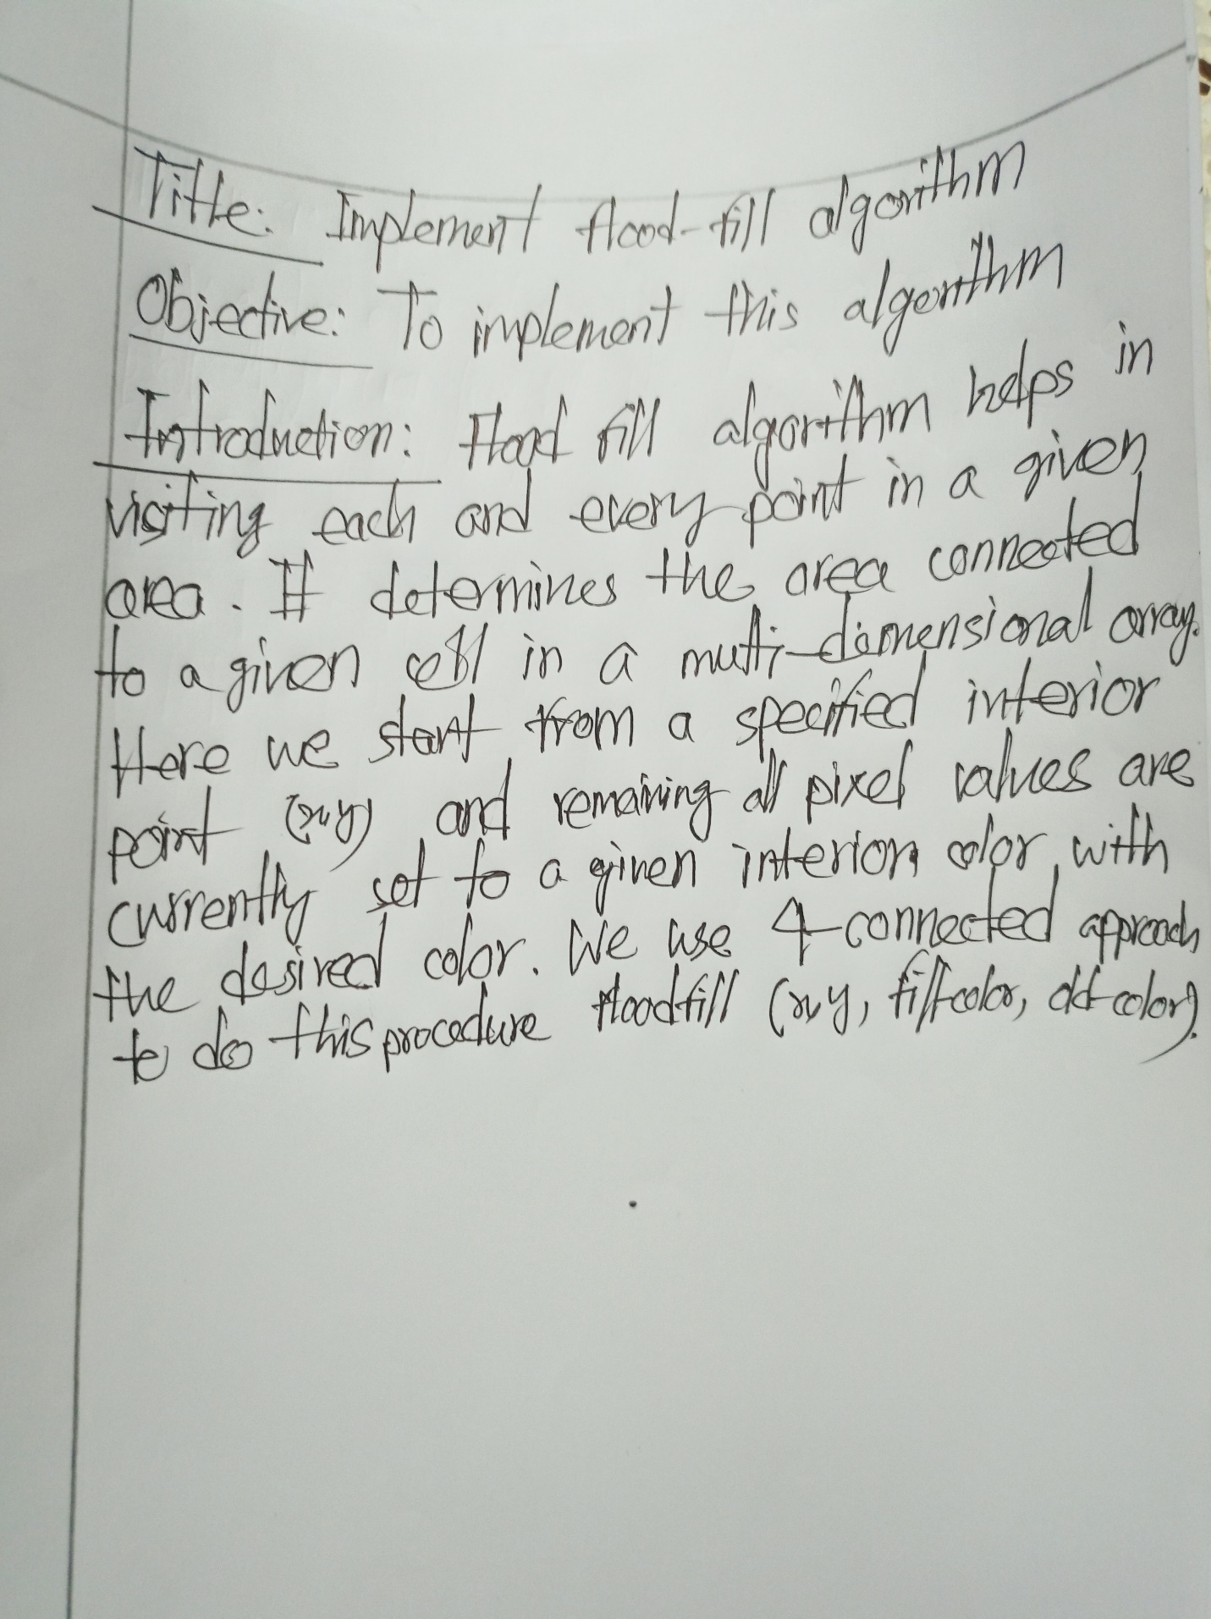

**Code:**

#include<windows.h>

#include<GL/glut.h>

#include<bits/stdc++.h>

using namespace std;

float bdcolor[] = {1.0, 0.0, 0.0};

float fillcolor[] = {1.0, 1.0, 0};

void algo(int x, int y) {

float color[3];

glReadPixels(x, y, 1.0, 1.0, GL_RGB, GL_FLOAT, color);

bool temp1 = (color[0] != bdcolor[0] || color[1] != bdcolor[1] || color[2] != bdcolor[2]);

bool temp2 = (color[0] != fillcolor[0] || color[1] != fillcolor[1] || color[2] != fillcolor[2]);

if(temp1 && temp2) {

glColor3f(fillcolor[0], fillcolor[1], fillcolor[2]);

glBegin(GL_POINTS);

glVertex2i(x, y);

glEnd();

glFlush();

int temp3[] = {x + 1, x - 1, x, x};

int temp4[] = {y, y, y + 1, y - 1};

for(int i = 0; i < 4; i++)

algo(temp3[i], temp4[i]);

}

}

void generate_shape() {

glColor3f(1.0, 0.0, 0.0);

glBegin(GL_LINE_LOOP);

int temp5[] = {85, 215, 310, 250, 200, 150};

int temp6[] = {200, 280, 200, 100, 150, 100};

for(int i = 0; i < 6; i++)

glVertex2i(temp5[i], temp6[i]);

glEnd();

glFlush();

}

void init(void) {

glClearColor (0,0,0,0);

glMatrixMode(GL_PROJECTION);

glLoadIdentity();

gluOrtho2D(0, 640, 0, 480);

}

int main(int argc, char** argv)

{

glutInit(&argc, argv);

glutInitDisplayMode (GLUT_SINGLE | GLUT_RGB);

glutInitWindowSize(640, 480);

glutInitWindowPosition(100, 100);

glutCreateWindow ("1604085 / lab 9");

init();

glutDisplayFunc([]() {

generate_shape();

algo(200, 200);

});

glutMainLoop();

return 0;

}

**Output:**



